Arab Welfare Association



School Policy
Contents
AWA School Aim and Objectives 3
Aim: 4
Objectives: 4
Admissions Policy 4
Admission Window 5
Admissions Process 5
Admission Fees 5
Payments 5
Curriculum Policy 6
Kitabi Book Series 7
Islamic Studies – Grenada Book Series 7
Attendance Policy 8
Timing 9
Location 9
Responsibilities 10
Pick and Drop Off Locations 11
Attendance types 12
parent school communication policy 13
Uniform Policy 14
Parent Afternoons 14
Location 14
Timing 14
End of Year Exams policy 15
End of Year Graduation ceremony policy 15
Homework Policy 15
Venue and facilities management 15
Behaviour Policy 16
Roles and responsibilities 17
Rewards Procedure 18
Warnings 20
Behaviour form template: 22
Detentions 23
Isolating Students 23
Confiscation 23
Child Protection and Safeguarding Children Policy 24
Policy statement and principles 24
Important contact details: 24
Whole school approach to safeguarding 25
Identifying Concerns 26
Indicators of abuse and neglect 27
Safe Staff and Safe Recruitment 30
Responsibilities 31
Training 38
Taking action where concerns are identified 38
Record Keeping 40
Confidentiality and Information Sharing 41
Privacy Notice to Students and Parents 55
Your rights 56
Food and allergy policy 57
Appendix (updated yearly) 59
List of staff / Teachers and classes table 59
School Calendar 60
School Map and classes 61

AWA School Aim and Objectives

AWA School is a weekend educational institution dedicated to delivering high-quality education to the Arabic and Muslim community in Slough and its surrounding areas. The school provides a nurturing environment where students can develop their academic, linguistic, cultural, and spiritual identities.

Aim:
AWA School aspires to be a leading institution in Arabic and Islamic education, helping young people embrace and uphold Islamic principles while excelling academically and socially in a multicultural, globalised world.

AWA School strives to equip students with the knowledge and skills to navigate the complexities of growing up in the West, ensuring they maintain a strong connection to their Islamic identity while developing the necessary tools to succeed in diverse environments. Our curriculum is carefully designed to nurture Islamic character, cultivate empathy, and promote a sense of responsibility towards their community."

Objectives:
- Educational Programme Overview: The AWA School, an initiative of the Arab Welfare Association since 2004, offers a well-rounded educational programme tailored for students aged 5 to 16. The curriculum balances core subjects such as reading, writing, and grammar with practical conversational training, aimed at enriching students’ linguistic skills. By integrating both modern and classical Arabic, the school nurtures linguistic versatility, helping students communicate effectively in both every day and formal settings.

- Quran and Islamic Studies: In addition to linguistic development, AWA School provides lessons in Quranic studies and Islamic education. These subjects are designed to foster both academic and spiritual growth, with a focus on instilling Islamic values, ethics, and a deeper understanding of religious teachings. The school’s Quranic and Islamic Studies curriculum goes beyond memorisation to promote understanding and practical application of Islamic teachings. This includes fostering qualities of compassion, respect, and community responsibility in students.

Admissions Policy

Admission Window
Arab Welfare Association school usually only accepts new applications for pupils to start in September which is the beginning of the academic year. The school avoids mid-year admissions in order to avoid disruption to pupils’ education and learning. More importantly, the school does not usually have spaces in classes once the academic year starts. However, the school may accept a mid-year application for exceptional circumstances. Pupils are admitted by selection. The final decision of admittance is the headteacher prerogative.

Admissions Process
Admissions forms are downloadable from the school’s website – www.awaschool.org/registration or collected from the main reception of the of the AWA School on Saturdays during school hours (9:00 AM to 1.30 PM).

Once the application form is submitted, parents/guardians of the child are invited to a short selection process with their child. The process involves an assessment of the child’s ability in reading and writing Arabic as well as their comprehension of basic Islamic principles.

The school then decides on suitable applicants. The school usually accommodates most applicants providing they meet the criteria, however parent/guardians will be informed if the AWA School is not able to accommodate their child.

The AWA School organises pupils in terms of Arabic language ability. This means older pupils maybe placed with younger pupils, however if the child progresses well during the academic year, AWA School will encourage pupils to move up a class.

Admission Fees
Parents are expected to pay the education fees of their child. Payments are to be made on the dates outlined in the below table. The AWA will send regular reminders ahead and post these dates, and reserves the right to take appropriate measures, which may include issuing penalties or suspending students, in cases of overdue payments.

Please note the below 2024/2025 AWA School Fees:

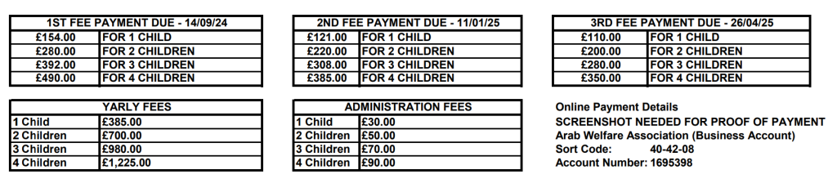

Books costs are additional to the above tends to fluctuate every year, and are therefore confirmed at the beginning of the year.

Payments

Online Payments are to be made payable to

Arab Welfare Association (Business Account)
Sort Code: 40-42-08
Account Number: 1695398

Curriculum Policy

The AWA School recognises the importance of therefore choosing a curriculum which aims at serving the young and growing Muslims of tomorrow who are mostly non-Arabic speakers.
For that reason, we have chosen the following curriculums as foundations of education for your child:

Kitabi Book Series

The Kitabi Arabic language book series is a comprehensive set of educational resources designed for learners of Arabic, particularly those in non-Arabic-speaking countries. It is structured to build foundational Arabic language skills through a progressive curriculum that covers the basics of reading, writing, listening, and speaking. The series typically includes interactive exercises, audio-visual aids, and culturally relevant contexts to support language immersion.
Key aspects of the Kitabi series:
- Gradual Skill Building: Starts from the Arabic alphabet, advancing to sentence structure and grammar.
- Engaging Activities: Includes exercises to reinforce vocabulary, reading comprehension, and conversational Arabic.
- Cultural Insights: Provides context about Arabic-speaking cultures, making it appealing for learners interested in cultural as well as linguistic immersion.
- Audio and Visual Materials: Often comes with audio resources for pronunciation and listening practice, aiding learners in developing an authentic accent and understanding.
The series is widely used in schools, community programs, and self-study, especially for those seeking to achieve fluency at a beginner or intermediate level.

Islamic Studies – Grenada Book Series

Adopted by ISESCO, the Granada series is designed with an effective, modern teaching approach, adapted to the cultural, intellectual, and psychological characteristics of learners.
This is an integrated learning and education curriculum prepared by a team of professional experts. The curriculum covers five levels of study (Pre-K to level five) and motivates Muslim children to learn Arabic and build a strong Islamic personality – teaching them to be proud of their Muslim identity, open-minded, and aware of the society around them. With the use of modern methods and techniques, this series takes the learner gradually from easy to challenging, and from simple to complex.
Getting familiar with the five pillars of Islam After the identification step, this level helps you to discover the Islamic religious practices. It is with this in mind that you discover simply and clearly the five pillars of Islam as well as certain universal values and essential knowledge on God and his Prophet Mohamed (PSUH)
Features
- Arabic only
- Qur'an
- Suras
- Stories of prophets
- Modern methodology

Attendance Policy

Timing
Drop off and pick up: Children are to be dropped off at school from 8.45 till 9:00 but not earlier as we are not permitted to be in the school premises, and need to be picked up promptly at 1:30.
Please ensure the children are dropped at school and are ready for the assembly at promptly 09:00am. This is essential to settle the children and not have further disturbance once the class has commenced. Missing 10/15 minutes of the class does add up over the course of the year.
Please note that we need to leave the premises by 2pm. therefore staying in the playground with your children at the end of the day will not be permissible any more for safety reasons
On the first day of school (17th September 2023) all students are to are to be dropped off at the school’s entrance and they be shown to their class room.
Below tables illustrates classes timetable.
Junior Classes
08:45 |  | School Drop off
09:00-09:15 | School Assembly
09:15-10:30 | First Lesson: Arabic
10:30-10:50 | 1st Break
11:50-12:00 | 2nd Lesson
12:00-12:30 | Lunch
12:30-13:30 | 3rd Lesson
13:30 | School Pick up
Senior Classes
08:45 |  | School Drop off
09:00-09:15 | School Assembly
09:15-10:30 | First Lesson: Arabic
10:30-10:50 | 1st Break
11:50-12:00 | 2nd Lesson
12:00-12:30 | Lunch
12:30-13:30 | 3rd Lesson
13:30 | School Pick up

Please inform the class teacher or school management if your child is expected to be absent from school for your family holidays or special occasions; or been absent due to illness.

The Main school door will be locked from 09:15 am and will not be open till 1:30pm

Location
Children are to be dropped off and picked up from the play area just outside the school, located in the below figure:
Parents will not be permitted into the school premise without teachers or staff permission.
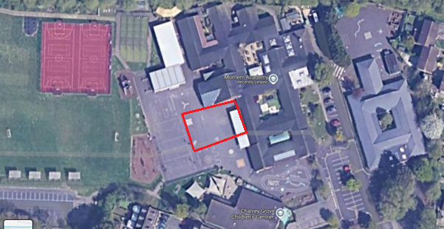

Responsibilities
  - Class teachers Class teachers are responsible for recording attendance on a daily basis, using the correct codes, and submitting this information to the school office this needs to be completed on the staff shared every lesson.

- Class teacher is not to leave the class unless an assistant is present.

- All School preparation and printing for the class to be done outside of class time (either the week ahead or during assembly or during lunch/break.

- 3.6 School admin staff School admin staff will take attendance records from the teacher and keep the attendance logs (soft copies) updated.

Pick and Drop Off Locations
Parents bring their child to the normal main entrance near the Sports Hall. Staff members will be available at these locations to guide the children safely to and from their classes. No Parent will be allowed to enter inside the school.
Pick up locations - No Parent will be allowed to pick up their child from inside the school. Children will be picked up from the class and halls external doors. Please see the pickup location for each class in the below table and map:
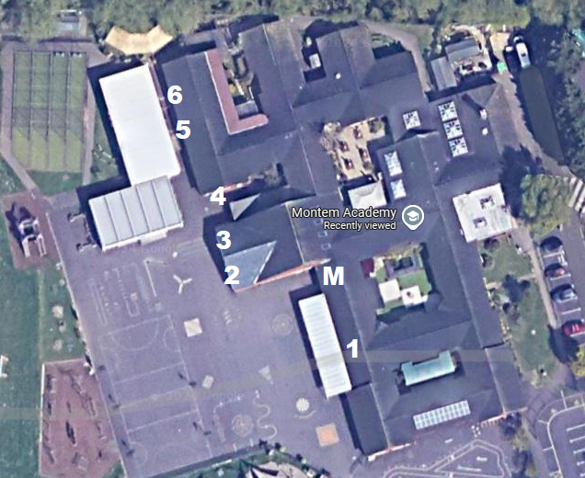
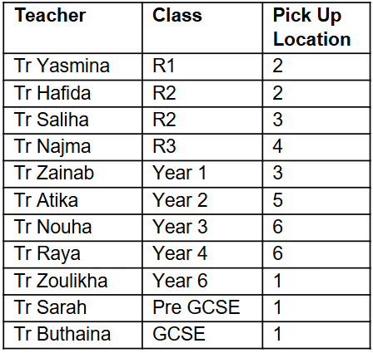

Attendance types

Code | Definition | Scenario
P | Present | Present at morning registration
L | Late arrival | Arrival after morning registration
A | Absent | Student is absent for the day
AA | Authorised Absence | Parents notice given for absence
I | Illness | Parent has notified that child is ill

parent school communication policy

There are 3 main contact points with the AWA school:

- WhatsApp group – This is a 2-way channel used for school announcements, parents informing school of absence. Parents are to ensure that the primary phone number is indicated on the application form, saves the AWA School number in the contact list.

The School WhatsApp number is: 07767 979 893

- School Admin Emails: This is a 2-way communication channel used for registration, general school queries, books/fees information/ follow ups, and general school announcements.

The School admin Email is: Admin@AWASCHOOL.ORG

- Teacher individual school Emails: This is a 2-way communication channel used to communication personal child progress, issues, concerns.

Please see below list of individual School Teach Emails:

Teacher | Class | Email
Yasmina | R1 | Yasmina.R1@awaschool.org
Hafida | R2 | Hafida.R2@awaschool.org
Saliha | R2 | Saliha.R2@awaschool.org
Nedjma | R3 | Nedjma.R3@awaschool.org
Zainab | Yr1 | Zainab.Yr1@awaschool.org
Atika | Yr2 | Atika.Y2@awaschool.org
Nouha | Yr3 | Nouha.Yr3@awaschool.org
Raya | Yr4 | Raya.Yr4@awaschool.org
Zoulikha | Yr6 | Zoulikha.Yr6@awaschool.org
Sarah | Pre GCSE | Sarah.PreGCSE@awaschool.org
Buthaina | GCSE | Buthaina.GCSE@awaschool.org

Uniform Policy

All students are expected to dress modestly and apply the Islamic dress code. Boys are not expected to come wear shorts above the knee, while the girls are expected to cover their heads all the time during school.

All students and staff are required to dress modestly and in accordance with Islamic guidelines. Students who are not in compliance with the dress code will be deemed to be in violation of AWA School rules of behaviour.
Parents are encouraged to assist their children by providing the appropriate clothing that fit the dress code.

Shoes must be work; flip flops, sandals will not be allowed, Excessive jewellery will not be allowed

Parent Afternoons

The AWA School holds 1 Parent-Teacher meetings during the academic year. This is usually held in March of every year.

Location
Parent Teacher meetings are conducted at the AWA School Premise, and specifically in the Sports hall.

Timing
Parent Teacher meetings are held immediately after school (in the afternoon). Slots for Parent meetings are to be booked in advance of the day. Parents will given ample notice to book slots with their child’s teacher.

End of Year Exams policy

The AWA School carries out 3 end of term exams throughout the academic year. One at the end of every term: November, February and June.

End of Year Graduation ceremony policy

To celebrate student graduations and achievements, the AWA School holds an annual end of year graduation ceremony. This usually entails shows and plays by the students to showcase their learning and is capped with handing out of graduation certificates and gifts for high achievers.

Homework Policy

Homework will be given to the pupils. It is the responsibility of each class teach to set the homework and provide it to each student. Homework is set using the blue booklets.

It is the parents’ responsibility to review the homework set for the week and signing off the sheet confirming their child has completed the homework.

Parents are reminded that the AWA School is held once a week, this makes completing the homework more important than usual as it acts to supplement the child’s learning

Venue and facilities management

AWA School is conducting all of its classes and education at Montem Academy. The rental agreement includes usage of toilets, assembly hall and outside play areas. All of these facilities are free to use by students. We ask that all parents and students avoid causing damage to any of the venue’s facilities. Damage costs caused by the child shall be reimbursed by the parents.

Behaviour Policy

Misbehaviour is defined as:

- Disruption in lessons, in corridors between lessons, and at break and lunchtimes

- Non-completion of classwork or homework

- Poor attitude Incorrect uniform

- Use of Mobile phones during class time

Serious misbehaviour is defined as:

- Repeated breaches of the school rules
- Any form of bullying or child-on-child abuse

- Sexual violence or harassment such as: Sexual comments Sexual jokes or taunting Physical behaviour like interfering with clothes etc.

- Possession of any prohibited items. These are:

  - Knives or weapons
  - Alcohol
  - Illegal drugs
  - Stolen items
  - Tobacco and cigarette papers
  - Fireworks
  - Pornographic image.
  - Any article a staff member reasonably suspects has been, or is likely to be, used to commit an offence, or to cause personal injury to, or damage to the property of, any person (including the pupil)

Roles and responsibilities

The headteacher
The headteacher is responsible for reviewing and approving this behaviour policy.

The headteacher will ensure that the school environment encourages positive behaviour, and that staff deal effectively with poor behaviour, and will monitor how staff implement this policy to ensure rewards and sanctions are applied consistently.

Staff
Staff are responsible for:

- Implementing the behaviour policy consistently
- Modelling positive behaviour
- Providing a personalised approach to the specific behavioural needs of particular pupils
- Recording behaviour incidents

The senior leadership team will support staff in responding to behaviour incidents.
Parents
Parents are expected to:

- Support their child in adhering to the pupil code of conduct
- Inform the school of any changes in circumstances that may affect their child’s behaviour
- Discuss any behavioural concerns with the class teacher promptly

Pupils
Pupils are expected to:
- Behave in an orderly and self-controlled way
- Show respect to members of staff and each other
- In class, make it possible for all pupils to learn
- Move quietly around the school
- Treat the school buildings and school property with respect
- Wear the correct uniform at all times
- Accept sanctions when given
- Refrain from behaving in a way that brings the school into disrepute, including when outside school

MERIT / REWARDS PROCEDURE

Our behaviour policy is designed to strike a balance between encouragement and discipline, fostering a positive learning environment. This approach promotes the development of students’ Islamic personalities while maintaining a structured system of accountability.

Rewards Procedure
To encourage positive behaviour, students are rewarded in the following ways:
- Verbal praise
- Merit points (based on the Merit Level system)
- Certificates and recognition during assemblies
- Letters or phone calls home to parents
- Special responsibilities or privileges
- Whole-class or year-group rewards (e.g., popular activities)
- Positions of responsibility, such as prefect roles or project leadership

Merit Levels
The AWA School implements a structured Merit Level system as follows:
- Merit Level 3 (10 points): Awarded for proven good performance or behaviour.
  - Reward: Certificate and additional lunch (5 minutes extra).
- Merit Level 2 (5 points): Awarded for no warnings issued during class time.
  - Reward: Stickers or similar recognition.
- Merit Level 1 (0 points): Applied when an informal warning or minor behaviour issue occurs during school time.
  - Consequence: Student remains in class 5 minutes longer before lunch.

Praise and Termly Rewards
Teachers incorporate praise throughout lessons to reinforce good behaviour, e.g.:
- At the start of lessons: "Well done for being prepared."
- During tasks: "Great effort on staying focused."
- At the end of lessons: "Thank you for tidying up quietly."
Termly rewards include:
- Additional stickers
- Extended lunch breaks (5-10 minutes)
- Certificates for students with the highest merit points
Merits may be awarded for:
- Outstanding performance in class
- Helping peers or teachers
- Politeness, patience, or compassion
- Organisation and tidying responsibilities
- Volunteering and supporting school events

The Headteacher may award extra merits for exceptional contributions, with badges and additional points given during assemblies.

Care needs to be taken when awarding merits and there should be:-

- A systematic approach
- Students should be treated fairly
- Some students already have excellent behaviour and they should be encouraged to excel in this.

Areas that merits are awarded for are as follows:

- Most merit points in Class
- Most merit points for a Class
- Attendance is at 100% every term
- Producing a good piece of work
- Making Good effort to complete a task
- For either helping teachers or for helping another student with a problem; for giving advice to students; encouraging others to have good behaviour; showing patience and giving something that they want to another student, etc.
- Showing compassion towards others
- Showing politeness towards teachers/other children
- Any other behaviour teachers feel deserves merits
- Volunteering to support other at any time
- For effectively tidying up at the end of each lesson; for good organisation of drawers and work; for helping the teacher tidy up when asked to do so.

This is not an exhaustive list, teachers may give merits where they see fit.

Headteacher also awards additional merits for exceptional work or attitude/behaviour. Students supporting assemblies, events and in admin are typically given merits by the headteacher.

Head teacher Gold/Silver Award Badge, can be awarded every week. The teachers are asked to nominate a student that has particularly excelled that week due to either work produced, good display of manners, or behaviour. All the students nominated by teachers are awarded 10 merits and awarded a badge at the school assembly or during class.

Warnings

Caution Procedure
If a student displays unacceptable behaviour, a structured Caution Level system is applied:

Warning Levels
- Warning Level 1 (-5 points):
  - Cause: First formal warning issued for misbehaviour.
  - Consequence: Student is sent to the admin office and misses half their lunch break.
- Warning Level 2 (-10 points):
  - Cause: Second formal warning or repeated misbehaviour.
  - Consequence: Student’s lunch break is removed for 1 school day.
- Warning Level 3 (-15 points):
  - Cause: Third formal warning or persistent misbehaviour.
  - Consequence: Student’s lunch break is removed for 2 school days.
- Warning Level 4 (-20 points):
  - Cause: Fourth formal warning or severe misbehaviour.
  - Consequence: Parent-teacher meeting arranged. Student is suspended for 1 school day.
- Warning Level 5 (-25 points):
  - Cause: Persistent or severe behaviour issues.
  - Consequence: Permanent exclusion from school.

Severe Behaviour
For serious behavioural incidents, the school reserves the right to suspend the student immediately.

Guidelines for Teachers
- Warnings must be logged systematically and behaviour points tracked fairly.
- Teachers should use positive language to encourage self-reflection (e.g., “You are choosing to behave this way”).
- Behaviour points are reset at the start of each term.

The above Merit and Warning system is summaries in the below flow chart:

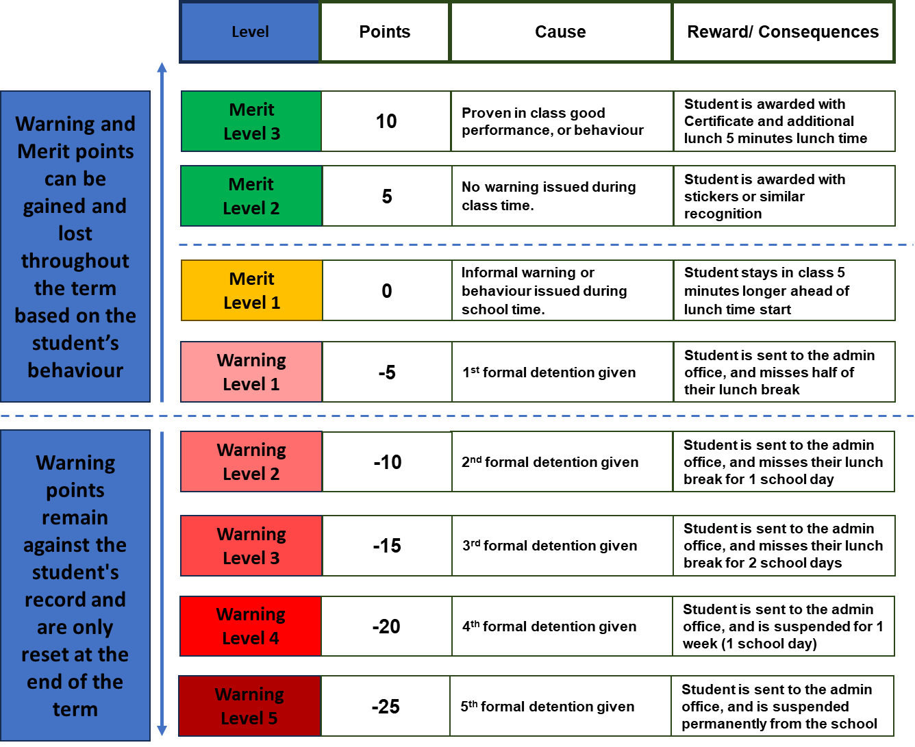

Behaviour form template:

Name | Merit/Warning Points

Detentions

If the teacher decides the sanction is a lunch-time or break time detention then the student’s name is added to the detention log. Students allocated break time detention are supervised by a teacher. If any students are in after school detention, the parents will be informed by a phone call home or text message.

Isolating Students

In certain circumstances, with more troublesome students who persistently disrupt lessons and teachers find the sanctions are being belittled and having no effect, it may be necessary to inform admin or the head of pastoral. The students will be asked to take their work and sit with another teacher for the rest of the day including break and lunch time. The admin will ensure parents are informed and students

Child Protection and Safeguarding Children Policy

Policy statement and principles
AWA School recognises its moral and statutory responsibilities for safeguarding children and protecting them from harm. We are committed to safeguarding children and young people. All staff who work in our school are expected to share this commitment. Adults in our school take all welfare concerns seriously and encourage children and young people to talk to us about anything that worries them. We will always act in the best interest of the child. We have clear systems and procedures in place to deal with any concerns and these are dealt with in a timely manner.
This Child Protection Policy will be reviewed and updated by the Designated Safeguarding Leads and the headteacher at least annually to ensure it remains current and incorporates all revisions made to local or national safeguarding guidance.
Key Personnel | Full Name | Contact details
Designated Safeguarding Lead (DSL) | Karima | CONFIRMED
Deputy DSL | Mustafa Jaddou | 07939323775
Headteacher | Kheyriya Abdul Wahid | CONFIRMED

Important contact details:
Slough Children First
Phone: 01753 875362
Email: sloughchildren.referrals@sloughchildrenfirst.co.uk.

The Multi-Agency Safeguarding Hub (MASH):
0345 050 7666 during office hours (8.30am – 5pm, Monday to Thursday, 8.30am – 4pm, Friday)
0800 833 408 Outside office hours call the Emergency Duty Team on

Local Authority Designated Officer (LADO)
Harvinder Rajansani
Email: LADO@sloughchildrenfirst.co.uk
Tel: 07927 681858 or 01753 690906.

Police
Emergency – 999
Non-emergency – 101
NSPCC Helpline
0808 800 5000

Safeguarding children
AWA School School recognises that safeguarding covers a broad range of areas and it aims to achieve the following:
• Protecting children from maltreatment.
• Preventing impairment of children’s mental and physical health and/or development.
• Ensuring children are growing up in circumstances consistent with the provision of safe and effective care.
• Enabling children to have optimum life chances, so they can enter adulthood successfully.
• Taking action to enable all children to have the best outcomes.

Whole school approach to safeguarding
• We understand the importance every member of our staff has through their contact with children in and outside of our school environment and the particular importance of the roles and relationships they have which places them in a position to identify concerns early, provide help for children and promote children’s welfare and prevent concerns from escalating.
• We have a responsibility to provide a safe environment in which children can learn.
• We will make every effort to identify children who may benefit from early help and put in place support as soon as a problem emerges at any point in a child’s life.
• Any staff member who has any concerns about a child’s welfare should follow the processes set out in this child protection policy and raise concerns with the designated safeguarding lead or deputy without delay.
• All our staff should expect to support social workers and other agencies following any referral, especially if they were involved in being alert to or receiving a disclosure of risk, harm or abuse or harassment from a child.
• Our designated safeguarding leads will provide support to staff to carry out their safeguarding duties and who will liaise closely with other services such as children’s social care, police, early help and health were required, as the designated safeguarding lead (and any deputies) are most likely to have a complete safeguarding picture and be the most appropriate person to advise on the response to safeguarding concerns.

Safeguarding is not just about protecting children from deliberate harm. It also relates to the broader aspects of care and education including:
• Pupils’ health and safety and emotional well-being, and their mental and physical health or development.
• Meeting the needs of children with special educational needs and/or disabilities.
• The use of reasonable force.
• Meeting the needs of children with medical conditions.
• Providing first aid.
• Educational visits and off- site education.
• Intimate care and emotional wellbeing.
• On-line safety and associated issues.
• Appropriate arrangements to ensure school security, taking into account the local context.
• Keeping children safe from risks, harm, exploitation and sexual violence and sexual harassment between children: KCSiE 2022 Annex A.

Identifying Concerns
All members of staff, volunteers and governors will know how to identify pupils who may be being harmed and then how to respond to a pupil who discloses abuse, or where others raise concerns about them. Our staff will be familiar with procedures to be followed.
Staff understand that abuse, neglect, and safeguarding issues are rarely standalone events that can be covered by one definition, and that in most cases multiple issues will overlap with each other. Staff who regularly come into contact with children are aware of the DfE guidance What to do if you're worried a child is being abused.
The four categories of child abuse are as follows:
1. Physical Abuse
2. Emotional Abuse
3. Sexual Abuse
4. Neglect

Indicators of abuse and neglect
Abuse: a form of maltreatment of a child. Somebody may abuse or neglect a child by inflicting harm or by failing to act to prevent harm. Children may be abused in a family or in an institutional or community setting by those known to them or, more rarely, by others. Abuse can take place wholly online, or technology may be used to facilitate offline abuse. Children may be abused by an adult or adults or by another child or children.
Physical abuse: a form of abuse which may involve hitting, shaking, throwing, poisoning, burning, or scalding, drowning, suffocating or otherwise causing physical harm to a child. Physical harm may also be caused when a parent or carer fabricates the symptoms of, or deliberately induces, illness in a child.
Emotional abuse: the persistent emotional maltreatment of a child such as to cause severe and adverse effects on the child’s emotional development. It may involve conveying to a chid they are worthless or unloved, inadequate, or valued only insofar as they meet the needs of another person. It may include not giving the chid opportunities to express their views, deliberately silencing them or ’making fun’ of what they say or how they communicate. It may feature age or developmentally inappropriate expectation being imposed o children. These may include interactions that are beyond a child’s developmental capability as well as over protection and limitation of exploration and learning or preventing the child from participating in normal social interaction. It may involve seeing or hearing the ill-treatment of another. It may involve serious bullying (including cyberbullying), causing children to feel frightened or in danger, or the exploitation or corruption of children. Some level of emotional abuse is involved in all types of maltreatment of a child, although it may occur alone.
Sexual abuse: involves forcing or enticing a child or young person to take part in sexual activities, not necessarily involving violence, whether or not the child is aware of what is happening. The activities may involve physical contact, including assault by penetration (for example rape or oral sex) or non-penetrative acts masturbations, kissing, rubbing, and touching outside of clothing. They may also include non-contact activities, such as involving children to look at, or in the production of, sexual images, watching sexual activities, encouraging children to behave in sexually inappropriate ways, or grooming a child in preparation for abuse. Sexual abuse is not solely perpetrated by adult males. Women can also commit acts of sexual abuse, as can other children. The sexual abuse of children by other children is a specific safeguarding issue (also known as peer on peer abuse) in education and all staff should be aware of it and of their school or colleges policy and procedures for dealing with it.
Neglect: the persistent failure to meet a child’s basic physical and/or psychological needs, likely to result in the serious impairment of the child’s health or development. Neglect may occur during pregnancy, for example, as a result of maternal substance abuse. Once a child is born, neglect may involve a parent or carer failing to; provide adequate food, clothing and shelter (including exclusion from home or abandonment); protect a child from physical and emotional harm or danger; ensure adequate supervision (the use of inadequate care-givers); or ensure access to appropriate medical care or treatment. It may also include neglect of, or unresponsiveness to, a child’s basic emotional needs.

Safeguarding can involve a range of other potential issues such as:
• Contextualised also known as extra-familial abuse.
• Bullying.
• Going frequently missing/ gong missing from care or home.
• Peer on Peer (child on child) abuse.
• Racist, disability- based, homophobic, bi-phobic, or transphobic abuse.
• Gender based violence/violence against women and girls.
• Risk of extremist behaviour and/or radicalisation.
• Child sexual exploitation, human trafficking, modern slavery, sexual or criminal exploitation.
• A young carer.
• Privately fostered
• The impact of new technologies, including ‘sexting’ and accessing pornography.
• Child on child sexual violence and sexual harassment (defined in KCSiE 2022 and DfE Sexual violence and sexual harassment between children).
• Issues which may be specific to a local area or population, for example gang activity, knife crime, youth violence, criminal child exploitation (CCE) and County Lines.
• Is in family circumstances which present challenges for the child, such as drug and alcohol misuse, adult mental health issues and domestic abuse/harm.
• Is at risk of or from serious violence and violent crime.
• Persistent absence from education, including persistent absence for part of the school day.
• Particular issues affecting children including domestic abuse and violence, female genital mutilation and honour-based abuse and forced marriage.
• ‘Upskirting’- The Voyeurism (Offences) Act, which is commonly known as Up-skirting Act, came into force on 12 April 2019. Upskirting is a criminal offence and reportable by all teachers (KCSiE 2022 and Annex A).
All our staff and volunteers are aware of the indicators of abuse and neglect and know what to look for is vital for the early identification so that support can be put in place. Our staff and volunteers are also aware of the specific safeguarding issues that indicate or inform of concerns or incidents linked to child criminal exploitation and child sexual exploitation and know to report concerns directly to the designated safeguarding at the earliest opportunity.
We are aware that abuse, neglect, and safeguarding issues are rarely standalone events and cannot be covered by one definition or one label alone. In most cases, multiple issues will overlap with one another, therefore all staff should always be vigilant and always raise any concerns with the designated safeguarding lead (or deputy).

AWA School also understands the importance of contextual safeguarding, i.e. that incidents or behaviours can be associated with factors outside home or school and can occur between children outside of school. All staff should be considering wider environmental factors that are present in a child’s life which are a threat to their safety and/or welfare. This information will also form part of any referrals the school makes, if the school considers this appropriate.
We also ensure that all our staff are clear that whilst they should discuss and agree with the DSL. any actions to be taken, they are able to escalate their concerns and contact MASH, or social care to seek support for the child if despite the discussion with the DSL their concerns remain. Staff are also informed of the Trust’s whistleblowing procedures and the contact details for the Local Authority LADO and NSPCC helpline.
The Designated Safeguarding Lead (DSL) and/or headteacher, who is familiar with national and local guidance, will share concerns, where appropriate, with the relevant agencies.
The DSL and deputies (DSL team) maintain a key role in raising awareness amongst staff about the needs of children who have or who have had a social worker and the barriers that those children might experience in respect of attendance, engagement and achievement at schools or college, see KCSiE 2022 page 147.
The DSL along with the Designated Teacher can inform the Headteacher of the number of children in their cohort who have or who have had a social worker and appropriate information is shared with teachers and staff on individual children’s circumstances.
The Designated Safeguarding Lead maintain data for children who have looked after status and for children who have been involved in the care system.

Safe Staff and Safe Recruitment
• The leadership team will ensure that all safer working practices and recruitment procedures are followed in accordance with the guidance set out in KCSiE 2022 Part Three and advised by the Trust HR Service, policy and best practice guidance.
• School leaders and staff will be appropriately trained in safer working practices and access the safer recruitment training where necessary.
• Statutory pre-employment checks and references from previous employers are an essential part of the recruitment process. We will ensure we adopt the appropriate necessary procedures to carry out the checks required and were any concerns arise we will seek advice and act in accordance with national guidance.
• The school has in place recruitment, selection and vetting procedures in accordance with KCSiE 2022 Part Three and maintains a Single Central Record (SCR), which is reviewed regularly and updated in accordance with KCSiE 2022 Part Three paragraphs 250 to 256.
• Staff will have access to advice on the boundaries of appropriate behaviour and will be aware of the School Employee Code of Conduct, which includes contact between staff and pupils outside the work context and low-level concerns.
• Newly appointed staff and volunteers will be informed of our arrangements for safer working practices by their line manager or other appropriate member of staff before beginning working and contact with pupils.
• In the event of any complaint or allegation against a member of staff, the headteacher (or the Designated Safeguarding Lead) if the headteacher is not present, will be notified immediately. If it relates to the headteacher, the DSL will be informed without delay. We will respond to all allegations robustly and appropriately in collaboration with the Local Authority Designated Officer (LADO) LADO/Allegation Officer.
• Staff may find some of the issues relating to child protection and the broader areas of safeguarding upsetting and may need support which should be provided by the school.
• Advice and support will be made available by the Safeguarding Children in Education Officer (SCiEO) and LADO where appropriate to the leadership team.
• All new employees will be appropriately inducted to their role and the Trust’s induction checklist will be followed and records kept. Records will also be kept about safer induction of supply staff, volunteers and contractors and visitors.

Responsibilities
AWA School recognises that safeguarding and promoting the welfare of children is everyone’s responsibility. Everyone who comes into contact with children and their parents, those with parental responsibility or carers has a role to play in safeguarding children.
All staff who work directly with children must read Part One and Annex B of KCSIE 2022. Staff who do not work directly with children can read the summary of Part One, where this is considered to be appropriate.
All staff must:
• Provide a safe environment in which children can learn.
• Be able and prepared to identify any child in need of early help.
• Be able to reassure victims that they are being taken seriously and will be supported and kept safe. Staff should never give the impression that reporting abuse causes problems, and victims should not feel ashamed.
• Be aware of the role of the DSL, including how and when to contact them.
• Follow the school’s reporting structures for safeguarding concerns which reflect those outlined in KCSIE 2022.
• Be able and prepared to deal with any safeguarding concern including knowing who to speak to and understand how to deal with sharing information and confidentiality issues.
• Be aware of, and act on, the contents of (a) this Child Protection Policy which covers all peer-on-peer abuse; (b) the Behaviour Policy (which includes measures to prevent bullying, including cyberbullying, prejudice, and discriminatory bullying). In addition, staff must be aware of and understand their Code of Conduct/Staff Behaviour Policy.
• Receive appropriate training about safeguarding and child protection, which is updated via email or bulletins at least annually or as required.
• Understand the child protection process, including Section 17 and Section 47 of the Children’s Act 1989 and multi-agency meetings, and be aware of local arrangements for the early help process (sometimes referred to as the common assessment framework), understanding their role in each.
• Be aware of what to do if a child tells them about being abused, neglected, or exploited.
• Be able to recognise physical abuse, emotional abuse, sexual abuse, and neglect, as well as safeguarding issues surrounding child sexual exploitation (CSE), child criminal exploitation (CCE) including county lines, peer-on-peer abuse, serious violence, and female genital mutilation (FGM) - AND understand that often safeguarding issues overlap.
• Be aware that safeguarding concerns can be linked to or caused by factors in a child’s wider environment outside of the family, such as sexual and criminal exploitation, and serious youth violence. This is often referred to as contextual safeguarding.
• Be aware that mental health issues can be a significant indicator of abuse or neglect.
• Be able to report concerns about safeguarding arrangements within their school and know not to hesitate before doing so.
• Know what to do if a child is missing from education.
Further information to support staff to fulfil these responsibilities is contained throughout this policy and is covered in the schools safeguarding and related training programme.

The leadership team will, as part of their responsibilities:
• Will ensure that the school is compliant with all duties under legislation and statutory guidance such as KCSIE 2022. This includes making sure that policies, procedures, and training are effective.
• Ensure that a DSL is appointed from the school’s SLT who has the status and authority to carry out all of the DSL duties. The Governing Body will also ensure the DSL has the time, training, and funding to carry out the role.
• Together with senior teams and the DSL, the governing body will ensure all staff are appropriately trained in child protection and safeguarding issues both at induction and on an ongoing basis.
• Ensure that there is a whole-school approach to safeguarding, i.e. safeguarding and child protection should be at the front of thinking and should underpin relevant policies and procedures. Policies and procedures should all operate with the best interests of the child at their heart. They will further ensure that teaching safeguarding to children is integrated into the curriculum.
• Ensure that the school creates a culture that safeguards and promotes the welfare of children. This includes ensuring unsuitable people are not employed by the school and ensuring compliant safer recruitment practices are in place, e.g. making sure that those involved in recruitment are trained in safer recruitment.
• Ensure policies, procedures, and mechanisms are in place to fulfil safeguarding responsibilities to those students who are “looked after”.
• Ensure the school has effective policies on a range of safeguarding related areas (in line with all good practice and KCSIE 2022 - in particular, paragraph 85) including:
- Child protection and safeguarding (including paragraph 145 in respect of information about peer- on-peer abuse).
- Behaviour.
- Staff behaviour.
- Appropriate safeguarding arrangements for those who go missing from education.
- Low level concerns/handling allegations against staff where the threshold is not met.

• Ensure that the school has systems for dealing with safeguarding issues which are “well promoted, easy to understand and easily accessible for children confidently to report abuse, knowing their concerns will be treated seriously, and knowing they can safely express their views and give feedback.
• Ensure that these policies and procedures reflect the challenges SEND children can face in terms of safeguarding -e.g. communication barriers and increased risk of bullying - and allow for identification of any mental health issues that children may be experiencing.
• Ensure, when fulfilling their responsibility to teach children about safeguarding, that this learning is, where necessary, tailored and contextualised for individuals including more vulnerable children, victims of abuse and some SEND children.
• Ensure they are aware of and understand local arrangements for safeguarding and the school contributes to multi-agency working.
• Ensure that training for teaching staff reflects the Teaching Standards’ expectations around managing behaviour effectively.
• Ensure child protection files are maintained properly (Annex C of KCSIE 22 has a detailed list of this requirement).
• Ensure that the school recognises the importance of sharing information to keep children safe.
• Ensure the school has appropriate safer recruitment policies and procedures in place (see Part 3 of KCSIE 22), including - in maintained schools - ensuring that governors are appropriately DBS checked.
• Ensure that the school has more than one contact number for children (i.e. so that a child missing who is also a safeguarding concern has more than one responsible adult the school can contact).
• Ensure that any hire agreement or similar contract for use of school premises includes safeguarding requirements – any breach should lead to termination.
• Assess the impact of this policy in keeping children safe.
• Review and annually approve the safeguarding policy, ensuring it complies with all law, regulations, and good practice. They will also hold the headteacher to account for its implementation.
• Receive any allegations made against the headteacher.
• Where the school is a registered charity, ensure compliance with Charity Commission requirements around child protection and safeguarding.

The headteacher will, as part their responsibilities:
• Be responsible for the implementation of this and all related policies and procedures, ensuring that the outcomes are monitored.
• Meet regularly with the DSL and report to the leadership team regularly regarding the effectiveness of safeguarding and implementation of related policies.
• Ensure that the DSL has appropriate time, funding, training, and resources to fulfil all of their functions and ensure adequate cover in the event that the DSL isn’t available.
• Ensure that everyone connected to the school is aware of this policy including safeguarding and child protection procedures.
• Ensure that everyone connected with the school understands and follows this and connected policies.
• Ensures that everyone has appropriate training– at induction and regularly thereafter.
• Take a risk-based approach to the information visitors to the school should receive.
• Ensure safe recruitment practice is followed when recruiting for posts, and act as a case manager when an allegation is made against a member of staff or volunteer. This includes being the recipient of any low-level concerns (i.e. those that do not meet the threshold).
• Ensure the school has a robust system for gathering all appropriate checks in relation to all staff, volunteers, and visitors, including Section 128 checks for school governors.
• Ensure the school offers a safe environment via a robust health and safety policy and procedure to meet the statutory responsibilities for the safety of students and staff at the school.
• Ensure the relevant staffing ratios are met, where applicable.

The role of DSL includes:

• Being available in term time- this can (in exceptional circumstances) be remotely via Teams/Zoom Skype or other media if they are not physically in school during term time for staff, volunteers, parents, or students to provide advice and support on child welfare, safeguarding, and child protection matters.

• Being the point of contact for staff who have a concern about a child’s welfare, safeguarding, or a child protection issue, including where the concern involves a mental health issue.

• Acting as a point of contact for safeguarding partners - for example, the police in relation to Operation Encompass - and, where required, taking part in and contributing to strategic discussions and inter-agency meetings, and supporting other staff to engage with this process'.

• Liaising with other staff (as needed) - for example, pastoral teams or senior mental health leads
and SENCos - when referring matters to children’s social care, so that the reports are as holistic as
possible.

• Ensuring that account is taken of the risk to children outside of their families and considering whether children are at risk of abuse relating to exploitation and serious violence.

• Where a safeguarding concern has a mental health element, ensuring discussions are had with the
senior lead for mental health.

• Managing referrals to the Local Authority Children’s Services or other services (such as the police
where a crime has been committed), or to the Channel programme, or the DBS (where someone has
been dismissed or has left because of the harm they have caused or the risk of harm they pose to
children).

• Liaising with other agencies and partners in cases where early help is considered the most
appropriate response and contributing to any ongoing support and further assessments.

• Working closely with children’s social care and any child’s social worker – in particular where there is a statutory response, and ensuring that actions the school proposes to take do not jeopardise an
ongoing investigation.

• Where children’s social care do not investigate, the DSL should not be afraid to refer again or
challenge the decision. If the decision remains not to investigate, the DSL should look for other
support such as early help.

• Where there has been an allegation/report of sexual violence, the DSL will support by advising
the school how to proceed, including undertaking an immediate risk assessment of need (risk
assessments should be considered on a case-by-case basis for reports of sexual harassment). The
risk and needs assessment should include:
- The victim and how best to support them.
- Whether it is a single victim.
- The alleged perpetrator.
- Risks to other children.

The risk assessment must be dynamic and retained in electronic form.

• Taking the lead role in any decisions about sexual violence or sexual harassment which are reported to the school.

• Where an allegation is proved to be unsubstantiated, unfounded, false, or malicious, the DSL will
consider whether the person who made the allegation is in need of support for other abuse – and
whether the report could be a cry for help. If so, the DSL should consider whether or not to refer to
children’s social care.

• Where there has been an allegation against a member of staff which is judged to meet the threshold (for referral to the LADO), ensuring the child is not at risk and determining whether or not the case should be referred to children’s social care as a suspected abuse case.

• Being aware of local arrangements for Early Help.

• Being aware of all the local and national support systems in place for victims of sexual violence.

• Being the point of contact for all peer-on-peer reports, and being aware of issues and supporting
actions where consent or power balances are in issue - for example, in sexual violence reports.

• Making referrals (where appropriate) to the Cyber Choices programme when a child may be involved in cybercrime.

• Where a teacher reports FGM, deciding whether or not to refer the matter to children’s social care.

• Encouraging a culture of supportive engagement with parents/carers around safeguarding and child welfare – this is especially so in circumstances where the family may be encountering challenging circumstances.

• Ensuring children’s views are heard by encouraging a culture of listening, taking account of their wishes and feelings, and building trust between children and staff so that communication and reporting issues is most effective.

• Working with a range of colleagues to promote the educational outcomes of ‘children in need’ by understanding the extra challenges this cohort can face because of the safeguarding/welfare or child protection issues they have been involved in.

• Thinking about how the issues can affect attendance, engagement, and achievements for children.

• Knowing the cohort of students who have or have had a social worker and ensuring their academic
progress, attainment, and aspirations.

• Supporting teaching staff to help with any reasonable adjustments or extra support to assist the above group, recognising that even where statutory services support has ended, there can be long term consequences for the child.

• Sharing information (as appropriate) with staff to achieve these goals for this cohort.

• Providing support for staff so that they are confident about welfare, safeguarding, and child
protection issues - including during a referral process - and helping them to see the links between safeguarding and academic/pastoral support.

• In relation to child protection files the DSL must:
- Keep clear, accurate, up-to-date records of any concerns, actions taken, and how these were followed up. The DSL will also support staff to keep records in this way. Records must be held securely and only shared with those who need to know – in line with data legislation and regulations.
- Hold files separately from the main file. Transfering them to a new school as soon as possible and no longer than 5 days after the transfer, or 5 days after the start of a new term if the transfer is not in term time. The DSL must obtain a receipt for the file.
- Consider whether or not it is appropriate to inform a new school that a child is involved in a Channel programme.
- Have details of the local authority Personal Advisor appointed to guide and support a care leaver, and liaise with them as necessary regarding any issues of concern affecting the care leaver.
- Where a perpetrator transfers schools, make the new school aware of potential risks, protective factors, and any ongoing support the child is receiving.

In relation to policies and procedures, the DSL must ensure that:

• The school’s child protection policy and procedures are reviewed annually and always remains up to date – working with staff and governors to achieve this.

• Staff have access to and understand the school’s child protection policy and procedures, and it is available publicly to parents, who should also be made aware of the school’s role in the child protection process.

• Staff are aware of local safeguarding arrangements.

• The DSL should also receive appropriate training (including Prevent) to undertake all their role and
responsibilities, and this includes:

• Understanding about specific needs that can increase vulnerability as well as specific harms that put children at risk.

• Understanding the assessment process for referrals to LA, including those relating to early help and child protection.

• Attending conferences so that they can be an effective participant in the process(es) and understand the importance of information sharing with other agencies.

• Understanding how important their role is for providing information to children’s social care so that children can be safeguarded, and their welfare promoted.
• Understanding the effect adverse childhood experiences and trauma can have on children, including the impact it can have on behaviour, mental health, and educational outcomes.

• Understanding and being alert to the specific vulnerable groups such as children in need, with SEND, or with other health conditions.

• Being aware of local protocols and how to use them – for example, when contacting the police about a serious violent sexual offence such as rape.

• Being aware of the contact details for the local housing authority so that any issues of homelessness can be referred correctly and swiftly.

• Understanding the barriers that stop children from reporting issues and how to build trust to help
with this.

• Building a culture of listening and making sure the wishes and feelings of the children are considered and encouraging staff in the measures the school may put in place to promote this.

• Having the ability to keep accurate, detailed, secure written records of safeguarding and welfare
issues.

Training
AWA School ensures all staff complete safeguarding and child protection training as part of their induction. This is designed to ensure all staff:
• Understand the school’s safeguarding systems and
• Their responsibilities, and
• Can identify signs of possible abuse or neglect or exploitation,
• Know how to act upon any concerns they have.

Taking action where concerns are identified

The following procedures apply to all staff working in the school and will be covered by training to enable staff to understand their role and responsibility.

The aim of our procedures is to provide a robust framework which enables staff to take appropriate action when they are concerned that a child is being harmed or is at risk of harm.

The prime concern at all stages must be the interests and safety of the child. Where there is a conflict of interest between the child and an adult, the interests of the child must be paramount.

All staff are aware that very young children with those with disabilities, special needs or with language delay may be more likely to communicate concerns with behaviours rather than words. Additionally, staff will question the cause of knocks and bumps in children who have limited mobility which will include children visiting the site as well as those who are pupils.

If a member of staff suspects abuse, spots signs or indicators of abuse, mental health concerns or they have a disclosure of abuse made to them they must:

1. Make an initial record of the information on the same day, through the dedicated forms.
2. Report it to the DSL/deputy DSL immediately.
3. The DSL will consider if there is a requirement for immediate medical intervention, however urgent medical attention should not be delayed if the DSL is not immediately available.
4. Make an accurate factual record as soon as possible and within 24 hours of the occurrence, of all that has happened, including details of:
● Dates and times of their observations
● Dates and times of any discussions in which they were involved
● Any injuries
● Explanations given by the child / adult
● What action was taken
● Any actual words or phrases used by the child
● Any questions the staff member asked (remembering not to ask any leading questions)

5. In the absence of the DSL or their Deputy, be prepared to refer directly to Children’s Social Care (and the police if appropriate), if there is the potential for immediate significant harm or to carry out a no names consultation with LCSS, if appropriate.

Following a report of concerns, the DSL must:
- Decide whether there are sufficient grounds for suspecting significant harm, in which case a referral must be made to Children’s Social Care and the police if it is appropriate. The rationale for this decision should be recorded by the DSL.

- Normally the school should try to discuss any concerns about a child’s welfare with the family and where possible, seek their agreement before making a referral to Children’s Social Care. However, in accordance with DfE guidance, this should only be done when it will not place the child at increased risk or could impact a police investigation. Where there are doubts or reservations about involving the child’s family, the DSL should clarify with Children’s Social Care or the police whether the parents should be told about the referral and, if so, when and by whom. This is important in cases where the police may need to conduct a criminal investigation. The child’s views should also be taken into account.

- If there are grounds to suspect a child is suffering, or is likely to suffer, significant harm the DSL (or Deputy) must contact Children’s Social Care via MASH, sharing:
i. the known facts
ii. any suspicions or allegations
iii. whether or not there has been any contact with the child’s family.
The MASH can be contacted by phone on 0345 050 7666.

- If a child is in immediate danger and urgent protective action is required, the police must be called. The DSL/DDSL must then notify Children’s Social Care of the occurrence and what action has been taken.

- When a pupil needs urgent medical attention and there is suspicion of parental abuse causing the medical need, the DSL or their Deputy should seek immediate advice from the MASH about informing the parents, remembering that parents should normally be informed if a child requires urgent hospital attention. However, as in all cases, if it is felt this could put the child more at risk then all action should be taken in the best interests of the child.

- If there is not considered to be a risk of significant harm, the DSL/DDSL will either actively monitor the situation, consider the Early Help process or contact the LCSS for a no names consultation.

Record Keeping

● Staff will record any welfare concerns that they have about a pupil on the dedicated forms
And passe them without delay to the DSL. Records will be completed on the same day as the
incident/event is reported to the staff member, using the child’s words and facts, and
will be signed and dated by the member of staff.

● All safeguarding concerns, discussions and decisions (and justifications for those decisions) will be recorded in writing. If members of staff are in any doubt about recording requirements, they should discuss their concerns with the DSL.

● Safeguarding records are kept for individual children and are maintained separately from all other records relating to the child in the school. Safeguarding records are kept in accordance with General Data Protection Regulations (GDPR) and our own school GDPR policy and are retained centrally and securely by the DSL. Safeguarding records are shared with staff on a ‘need to know’ basis only.

● All safeguarding records will be transferred in accordance with GDPR to the child’s subsequent school/setting, under confidential and separate cover. These will be given to the new DSL and a receipt of delivery will be obtained.

● Our record keeping procedures are in line with the KCSiE guidance.

● The Headteacher will be kept informed of any significant issues by the DSL, if they
are not the DSL.

Confidentiality and Information Sharing

● AWA School recognises that all matters relating to child protection are confidential. The Headteacher or DSL will only disclose information about a pupil to other members of staff on a ‘need to know’ basis.

● All members of staff must be aware that whilst they have duties to keep any information confidential, they also have a professional responsibility to share information with other agencies to safeguard children.

● All staff must be aware that they cannot promise a child they will keep secrets which might compromise the child’s safety or wellbeing.

● There is a lawful basis for child protection concerns to be shared with agencies who have a statutory duty for child protection.

● Governing bodies and proprietors should ensure relevant staff have due regard to the relevant data protection principles, which allow them to share (and withhold) personal information, as provided for in the Data Protection Act 2018 and the GDPR.

● DfE Guidance on Information Sharing (July 2018) provides further detail.
https://www.gov.uk/government/publications/safeguarding-practitioners-information-sharing-advice

● OSCB provides advice on the Seven Golden Rules of Information Sharing
https://www.oscb.org.uk/wp-content/uploads/2019/07/The-Seven-Golden-Rules-for-Info-Sharing.pdf

● Guidance to support schools with Data protection activity, including compliance with
GDPR Data Protection Tool Kit

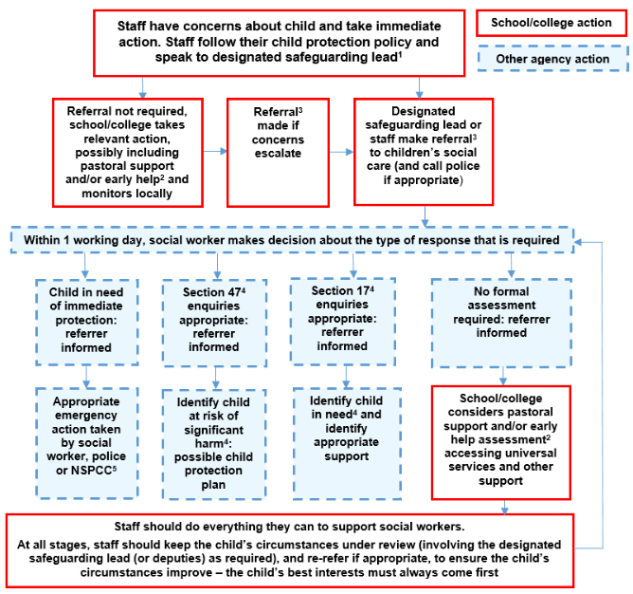
Appendix A: Actions when there are concerns about a child
1 In cases which also involve a concern or an allegation of abuse against a staff member, see the details in this guidance.
2 Early help means providing support as soon as a problem emerges at any point in a child’s life. Where a child would benefit from co-ordinated early help, an early help inter-agency assessment should be arranged (further details in Chapter one of KCSIE 2022).
3 Referrals should follow the process set out in the local threshold document and local protocol for assessment (further details in Chapter one of KCSIE 2022).
4 Under the Children Act 1989, local authorities are required to provide services for children in need for the purposes of safeguarding and promoting their welfare. Children in need may be assessed under section 17 of the Children Act 1989. Under section 47 of the Children Act 1989, where a local authority has reasonable cause to suspect that a child is suffering or likely to suffer significant harm, it has a duty to make enquiries to decide whether to take action to safeguard or promote the child’s welfare (further details in Chapter one of KCSIE 2022).
5 This could include applying for an Emergency Protection Order (EPO).
Appendix B

Case Record / Chronology | CONFIDENTIAL

Sheet Number:
Complete for all incidents of concern including where a ‘logging the concern’ sheet has not been completed. If one has been completed, then add a note to this chronology to cross reference (significant information may also be added).

Name:
DOB: |  | Form:
Date | Information/Details of concerns or contact | Print Name and Signature

Appendix C:

Logging a concern about a child’s safety and welfare

Part 1 (for use by any staff)

Pupil’s Name: | Date of birth: | FORM:
Date and Time of Incident: | Date and Time (of writing):
Name:
Print | Signature
Job title:
Note the reason(s) for recording the incident

Record the following factually: Who? What (if recording a verbal disclosure by a child use their words)? Where? When (date and time of incident)? Any witnesses?

Professional opinion where relevant (how and why might this have happened?)

Note actions, including names of anyone to whom your information was passed.

Any other relevant information (distinguish between fact and opinion).

Check to make sure your report is clear to someone else reading it
Please give this form to your Designated Safeguarding Lead

Part 2 (for use by the Snr Designated Safeguarding Lead (DSL)

Time and date information received
by DSL, and from whom
Any advice sought by DSL (date, time, name, role, organisation and
advice given)

Action taken (referral to MASH/children’s social
care/monitoring advice given to appropriate
staff/EHAF etc. with
reasons.
Note time, date, names, who information shared
with and when etc.

Parent’s informed
Y/N and reasons.

Outcome

Record names of individuals/agencies
who have given information regarding outcome of any referral (if made).

Where can additional
information regarding
child/incident be found (e.g. Pupil file, serious incident book)?

Should a concern/ confidential file be commenced if there is not already one? Why?

Signed
Printed Name

Body Map guidance for Schools

Medical assistance should be sought where appropriate.

Body Maps should be used to document and illustrate visible signs of harm and
physical injuries.

Always use a black pen (never a pencil) and do not use correction fluid or any other
eraser.

Do not remove clothing for the purpose of the examination unless the injury site is
freely available because of treatment.

*At no time should an individual teacher/member of staff or school be asked to or consider taking photographic evidence of any injuries or marks to a child’s person, this type of behaviour could lead to the staff member being taken into managing allegations procedures, the body map below should be used in accordance with recording guidance. Any concerns should be reported and recorded without delay to the appropriate safeguarding services, e.g. MASH or the child’s social worker if already an open case to social care.

When you notice an injury to a child, try to record the following information in respect of each mark identified e.g. red areas, swelling, bruising, cuts, lacerations and wounds, scalds and burns:

• Exact site of injury on the body, e.g. upper outer arm/left cheek.
• Size of injury - in appropriate centimetres or inches.
• Approximate shape of injury, e.g. round/square or straight line.
• Colour of injury - if more than one colour, say so.
• Is the skin broken?
• Is there any swelling at the site of the injury, or elsewhere?
• Is there a scab/any blistering/any bleeding?
• Is the injury clean or is there grit/fluff etc.?
• Is mobility restricted as a result of the injury?
• Does the site of the injury feel hot?
• Does the child feel hot?
• Does the child feel pain?
• Has the child’s body shape changed/are they holding themselves differently?

Importantly the date and time of the recording must be stated as well as the name and designation of the person making the record. Add any further comments as required.

Ensure First Aid is provided where required and record
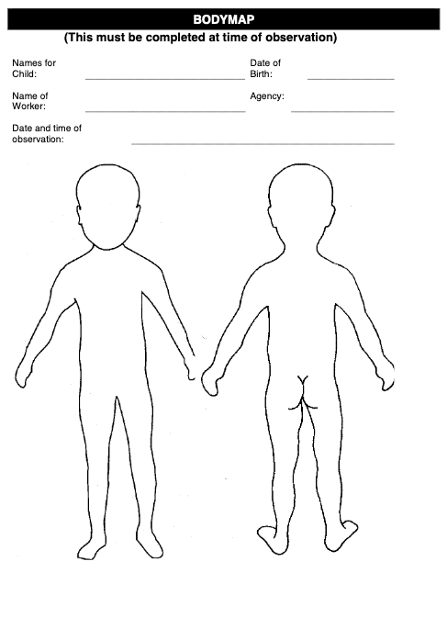
A copy of the body map should be kept on the child’s child protection file.

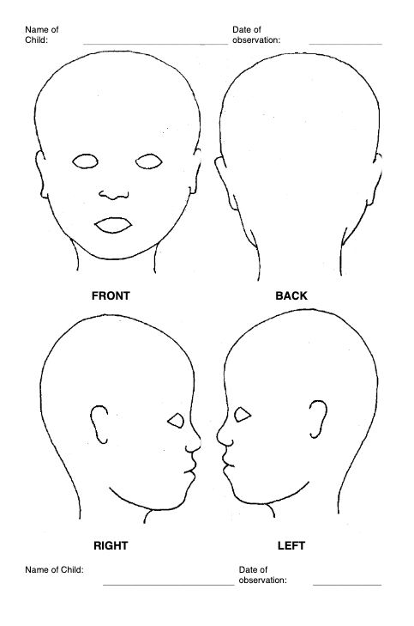

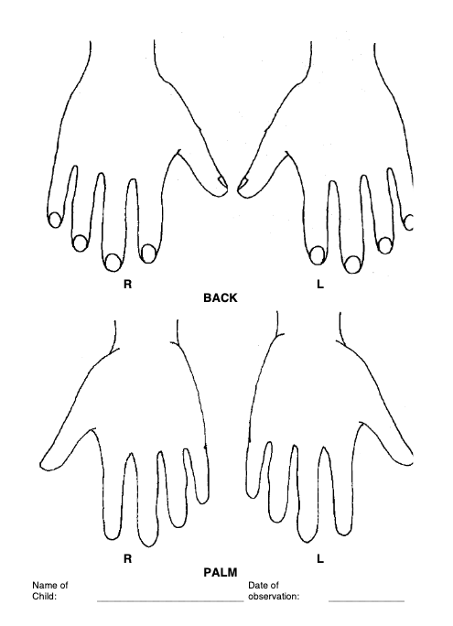
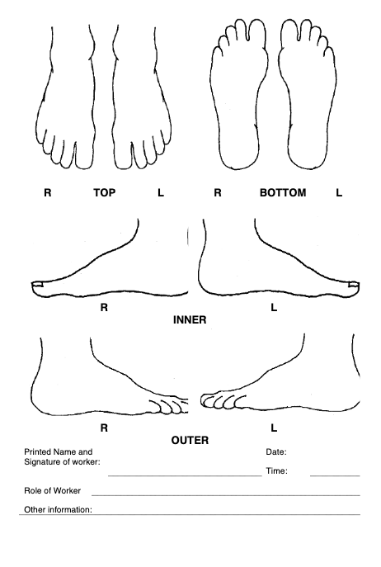

Privacy Notice to Students and Parents

The personal data we hold We hold some personal information about you to make sure we can help you learn and look after you at school. For the same reasons, we get information about you from some other places too – such as other schools, the local council and the government. Personal information that we may collect, use, store and share (when appropriate) about you includes, but is not restricted to: Your contact details Your test/exam results Your attendance records Details of any behaviour issues or exclusions We may also collect, use, store and share (when appropriate) information about you that falls into ‘special categories’ of more sensitive personal data. This includes, but is not restricted to: Information about your characteristics, like your ethnic background or any special educational needs Information about any medical conditions you have Photographs and CCTV images

Why we use this data We use the data listed above to: a) Get in touch with you and your parents or carers when we need to b) Check how you’re doing in exams and work out whether you or your teachers need any extra help c) Track how well the school as a whole is performing d) Look after your wellbeing

Use of your personal data for marketing purposes Where you have given us consent to do so, we may send you messages by email or text promoting school events, campaigns, charitable causes or services that you might be interested in. You can take back this consent or ‘opt out’ of receiving these emails and/or texts at any time by contacting us (see ‘Contact us’ below).

Our lawful basis for using this data The lawful bases for processing are set out in Article 6 of the UK GDPR. At least one of these applies whenever we process personal data: (a) Consent: the individual has given clear consent for you to process their personal data for a specific purpose. (b) Contract: the processing is necessary for a contract you have with the individual, or because they have asked you to take specific steps before entering into a contract. (c) Legal obligation: the processing is necessary for you to comply with the law (not including contractual obligations). (d) Vital interests: the processing is necessary to protect someone’s life. (e) Public task: the processing is necessary for you to perform a task in the public interest or for your official functions, and the task or function has a clear basis in law. (f) Legitimate interests: the processing is necessary for your legitimate interests or the legitimate interests of a third party, unless there is a good reason to protect the individual’s personal data which overrides those legitimate interests. (This cannot apply if you are a public authority processing data to perform your official tasks.) For more detail on each lawful basis, the guidance can be found online, linked here. Where you have provided us with consent to use your data, you may withdraw this consent at any time. We will make this clear when requesting your consent, and explain how you would go about withdrawing consent if you wish to do so.

Our basis for using special category data For ‘special category’ data (more sensitive personal information), we only collect and use it when we have both a lawful basis, as set out above, and 1 of the following conditions for processing as set out in UK data protection law: We have got your explicit consent to use your information in a certain way We need to use your information under employment, social security or social protection law We need to protect an individual’s vital interests (i.e. protect your life or someone else’s life), in situations where you’re physically or legally incapable of giving consent The information has already been made obviously public by you We need to use it to make or defend against legal claims We need to use it for reasons of substantial public interest as defined in legislation We need to use it for health or social care purposes, and it’s used by, or under the direction of, a professional obliged to confidentiality under law We need to use it for public health reasons, and it’s used by, or under the direction of, a professional obliged to confidentiality under law We need to use it for archiving purposes, scientific or historical research purposes, or for statistical purposes, and the use is in the public interest For criminal offence data, we will only collect and use it when we have both a lawful basis, as set out above, and a condition for processing as set out in UK data protection law. Conditions include: We have got your consent to use it in a specific way

How we store this data We keep personal information about you while you’re attending our school. We may also keep it after you stop attending our school, if this is necessary. Our record management policy sets out how long we keep information about parents and carers. The policy is available on our school website or is linked here. We have security measures in place to prevent your personal information from being accidentally lost, used or accessed in an unauthorised way, altered or disclosed. We’ll dispose of your personal data securely when we no longer need it. 7. Who we share data with We don’t share information about you with any third party without your consent unless the law and our policies allow us to do so. Where it’s legally required, or necessary (and it complies with UK data protection law), we may share personal information about you with: Our local authority, Bolton council – to meet our legal obligations to share certain information with it, such as safeguarding concerns and information about exclusions Government departments or agencies Our youth support services provider Our regulator, Ofsted Suppliers and service providers Financial organisations Our auditors Survey and research organisations Health authorities

Your rights

You have a right to make a ‘subject access request’ to gain access to personal information that we hold about you. If you make a subject access request, and if we do hold information about you, we will (unless there’s a really good reason why we shouldn’t): Give you a description of it Tell you why we are holding and using it, and how long we will keep it for Explain where we got it from, if not from you Tell you who it has been, or will be, shared with Let you know whether any automated decision-making is being applied to the data (decisions made by a computer or machine, rather than by a person), and any consequences of this Give you a copy of the information in an understandable form You may also have the right for your personal information to be shared with another organisation in certain circumstances.

Your other rights regarding your data Under data protection law, you have certain rights regarding how your personal information is used and kept safe. For example, you have the right to: Say that you don’t want your personal information to be used Stop it being used to send you marketing materials Say that you don’t want it to be used for automated decisions (decisions made by a computer or machine, rather than by a person) In some cases, have it corrected if it’s inaccurate In some cases, have it deleted or destroyed, or restrict its use Withdraw your consent, where you previously provided consent for your personal information to be collected, processed and transferred for a particular reason In some cases, be notified of a data breach Make a complaint to the Information Commissioner’s Office Claim compensation if the data protection rules are broken and this harms you in some way To exercise any of these rights, please contact us (see ‘Contact us’ below).

Complaints We take any complaints about our collection and use of personal information very seriously. If you think that our collection or use of personal information is unfair, misleading or inappropriate, or have any other concerns about our data processing, please let us know first.

Food and allergy policy

Although we recognise that this cannot be guaranteed, AWA School aims to be a Nut-Free school. This policy serves to set out the school’s policy in relation reducing the risk to those children and adults who may suffer a reaction if exposed to nuts to which they are sensitive.

If exposed to nuts, the student may develop a life-threatening allergic reaction that requires emergency medical treatment. Strict avoidance of nuts/peanuts is the only way to prevent a life-threatening allergic reaction. To eliminate the risk of exposure, the school will be peanut/nut-free. In doing so the school also requests the assistance of parents in providing the students with a safe learning environment, by ensuring strict adherence to this policy.

AWA School does not allow nuts or nut products in school lunch boxes.

Our “Nut-Free Policy” means that the following items should not be brought into school:

• Packs of nuts
• Peanut butter sandwiches
• Fruit and cereal bars that contain nuts
• Chocolate bars or sweets that contain nuts
• Sesame seed rolls (children allergic to nuts may also have a severe reaction to sesame)
• Cakes made with nuts

All product packaging must be checked for warnings directed at nut allergy sufferers and if the following or similar are displayed, the product must not be used at the school.
Packaging must be checked for:
• Not suitable for nut allergy suffers;
• This product contains nuts;
• This product may contain traces nuts;
• Indicating this is unsuitable for school consumption

Parents
We ask that all parents cooperate with this policy by not sending any peanut/nut containing snacks with their child to eat in the classroom. We ask that if children have eaten peanut or nut products before school, to ensure they wash their hands thoroughly before coming to school.

Parents and carers must notify staff of any known or suspected allergy to nuts and provide the medicines and all the necessary information.
Any sweets/cakes brought in from home cannot be given out as birthday treats etc.
Teachers
Following snack time, the children will wash their hands before returning to their seats.

Staff and volunteers will ensure they do not bring in or consume nut products in school and ensure they follow good hand washing practice.

Appendix 1: Foods to avoid - http://safereating.co.uk/problem-foods/tree-nuts-peanuts/
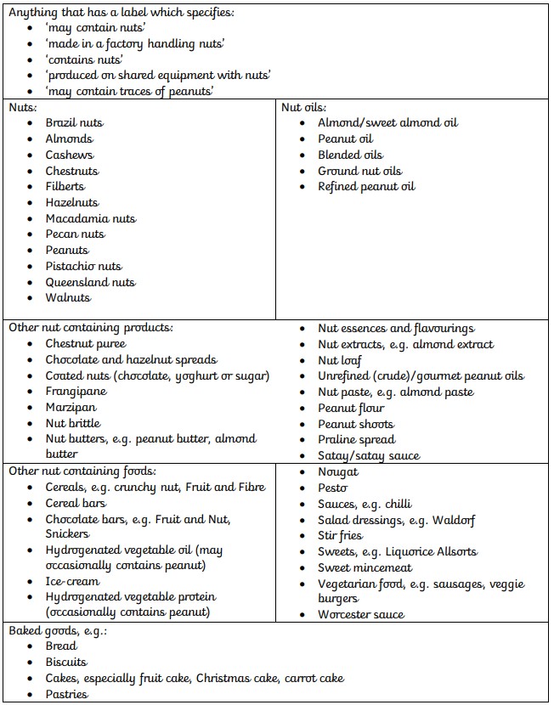

Appendix (updated yearly)

List of staff / Teachers and classes table

Teacher Name | Class
Tr Yasmina | R1
Tr Hafida | R2
Tr Saliha 2 | R2
Tr Najma R | R3
Tr Zainab | Year 1
Tr Atika | Year 2
Tr Nouha | Year 3
Tr Raya | Year 4
Tr Zoulikha | Year 6
Tr Sarah | Pre Gcse
Tr Buthaina | GCSE

School Calendar

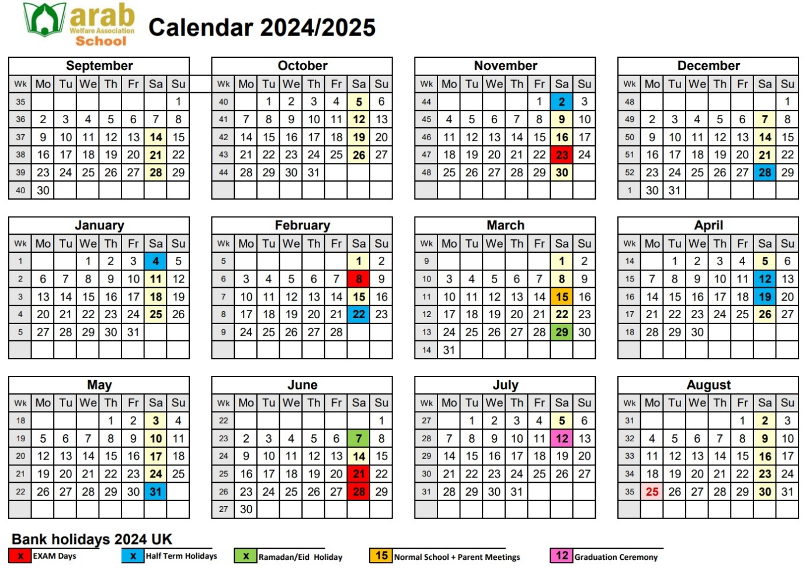

School Map and classes
